Analysis of MSDs Injuries in Loading and Unloading Activities Using the Rapid Entire Body Assessment (REBA) Method

Wafa Nurul Hakim
Department of Marine Logistics, Universitas Pendidikan Indonesia; Bandung, Indonesia
E-Mail: wafanh@upi.edu

Alyani Zalfaa
Department of Marine Logistics, Universitas Pendidikan Indonesia; Bandung, Indonesia

Ma’ruf
Department of Marine Logistics, Universitas Pendidikan Indonesia; Bandung, Indonesia

Raihan Naufaldi
Department of Marine Logistics, Universitas Pendidikan Indonesia; Bandung, Indonesia

Ridho Arief Firmansyah
Department of Marine Logistics, Universitas Pendidikan Indonesia; Bandung, Indonesia

ABSTRACT
PT. XYZ is a company that has a port in the field of loading and unloading goods and containers with wood commodity materials, basic necessities, grocery goods and building materials. PT. XYZ experienced problem related to loading and unloading activities for transporting commodity materials which were still carried out manually and involved transporting approximately 300 ton in 1 day. Workers complain of pain in certain parts of the body, giving rise to complain of musculoskeletal disorders (MSDs) due to unergonomic work postures. The method in this research uses the Nordic body map and rapid entire body assessment (REBA) questionnaires which are useful as problem solving steps by describing several odd work postures in porters and also a classification of action that need to be taken. From the calculation result, workers need heavy equipment or facilities for loading and unloading activities, this proposal can reduce work accidents which are influenced by unsafe action and unsafe condition as well as developing productivity, efficiency and effectiveness of loading and unloading at one of docks PT. XYZ.

Keywords: REBA, Injuries Musculoskeletal Disorders, Ergonomics, Nordic Body Map

ABSTRAK
PT.XYZ merupakan sebuah perusahaan yang memiliki pelabuhan pada bidang bongkar muat barang dan peti kemas dengan material komoditas kayu, kebutuhan pokok, barang kelontong, dan bahan bangunan. PT. XYZ mengalami permasalahan terkait aktivitas bongkar muat pengangkutan material komoditas yang dilakukan masih secara manual handling dan melibatkan pengangkutan kurang lebih sebanyak 300-ton dalam 1 hari. Pekerja memiliki keluhan nyeri pada bagian tubuh tertentu sehingga menimbulkan keluhan musculoskeletal disorders (MSDs) akibat postur kerja yang tidak ergonomis. Metode dalam penelitian ini menggunakan kuesioner Nordic Body Map dan Rapid Entire Body Assessment (REBA) yang berguna sebagai langkah pemecahan masalah dengan menguraikan beberapa postur kerja yang janggal pada kuli panggul dan juga adanya klasifikasi untuk tindakan yang perlu dilakukan. Dari hasil perhitungan, pekerja perlu dilakukan tindakan segera saat ini. Jika PT. XYZ melakukan pengadaan alat berat atau fasilitas pada aktivitas bongkar muat usulan ini dapat mengurangi kecelakaan kerja yang dipengaruhi oleh unsafe action dan unsafe condition serta keluhan musculoskeletal disorders (MSDs) serta mengembangkan produktivitas, efisiensi dan efektivitas bongkar muat di salah satu dermaga PT. XYZ.

Kata kunci: REBA, Cedera Musculosceletal Disorders, Ergonomi, Nordic Body Map

INTRODUCTION
PT.XYZ is a company that has a port in the field of loading and unloading goods and containers. Commodities transported at the port, in addition to wood, also include basic necessities, groceries, and building materials. One of the docks of PT. XYZ's port has high loading and unloading activities, causing increased working hours and heavy workloads for its workers. This loading and unloading process involves transporting materials from wooden ships to trucks, or vice versa, which is currently still done manually due to the lack of supporting equipment. Manual Material Handling (MMH) is the process of lifting/lowering, pushing/pulling, rotating, carrying, and holding a load manually carried out by humans over a certain period of time. Manual material handling carried out by porters at one of PT. XYZ's port docks involves carrying commodity materials weighing between 25-50 kg per sack, as well as transporting wood materials. In order for loading and unloading activities on one ship to run effectively, 15-20 porters are needed to work. In 1 day, the loading and unloading process totals 40 ships and 10 trucks that can be accumulated with a load of approximately 300 tons with the working hours of the porters from 8 am to 5 pm. The wages received are not commensurate with the risk of the work where for 1 ton transported the price paid is IDR 8,500. This causes a potential risk of accidents that can be caused by awkward work postures when carrying out repeated transportation activities with long working hours, heavy loads and minimal unloading equipment provided (Rahayu et al., 2022). The problems that occur when the process of moving commodity materials cannot be said to be ergonomic because it is still carried out with manual handling and the use of heavy equipment or facilities is also inadequate.
This can pose a risk to the work of porters in the form of diseases/injuries that initially arise from complaints of pain in the worker's body. one of the most common is an injury known as musculoskeletal disorders or Musculoskeletal Disorders (MSDs). According to the ILO, data on musculoskeletal complaints in Indonesia shows that workers experience muscle injuries in the lower neck (80%), shoulders (20%), back (40%), waist to back (40%), hips to back (20%), buttocks (20%), thighs (40%), knees (60%), and calves (80%) (ILO, 2018). According to previous research by Septini et al. (2022), entitled "Work Posture in Tuna Fish Loading and Unloading Activities at the Nizam Zachman Jakarta Ocean Fisheries Port". From the results of this analysis, tuna fish unloading activities at the Nizam Zachman Jakarta PPS showed that tuna fish unloading workers experienced complaints of back pain. The level of complaints is classified based on age where the age of <30 years is 42% for slightly sick and 9% for sick and for workers aged> 30 years is slightly sick by 52%, sick by 21%, and very sick by 2%. The part of the worker's pain was found in the back due to lifting heavy loads in a bent position. In the activities carried out by porters, both from previous research and this research, there are similarities in the behavior of incorrect work postures in transporting materials. With this, the ergonomic aspect becomes very relevant and important to consider. Ergonomics is a multidisciplinary science that is part of the science of Occupational Safety and Health (K3).
However, unfortunately, there are still shortcomings in the research conducted by Septiani et al. (2022), namely that there has not been a recommendation for an aid to make it easier for porters. However, in the suggestions section, it is explained that there must be further research regarding recommendations for aids to reduce work accidents in porters. This is in line with the purpose of this study, namely to provide an improvement by recommending an aid or facility in the process of transporting commodity materials that are useful for reducing excessive physical workloads and minimizing the risk of accidents. Therefore, research needs to conduct an analysis and evaluation of the work posture of porters at PT.XYZ with a method that uses the principles of ergonomics in the form of a Nordic Body Map questionnaire with a calculation method, namely the Rapid Entire Body Assessment (REBA). So that the recommended tools can be in accordance with the needs and specifications of the Phinsi ship for a more effective and efficient work process, as well as creating a safer work environment for workers.

LITERATURE REVIEW
Loading and unloading is an activity stage consisting of two continuous activities, consisting of operational activities of picking up landed goods, moving ship goods docked at the pier to the stacking yard or warehouse, placing, arranging, and stacking goods in the stacking yard or warehouse area and loading operational activities are the opposite stage based on unloading operational activities, in loading activities, goods move from the stacking yard or warehouse to ships docked at the pier which includes the activities of picking up goods, moving goods, placing goods, and lifting goods from the pier to the ship. According to Nurdiana (2020), "loading and unloading operations at the pier are activities of unloading imported goods and inter-island goods from the ship using a crane and ship sling to the nearest land at the edge of the ship which is commonly called the pier. Then from the pier using a lorry, forklift or pushcart it is entered and arranged into the nearest warehouse designated by the port administrator". Musculoskeletal is a vocabulary derived from the words Musculo (muscle) and skeletal (bone). Musculoskeletal disorders (MSDs) have a major role in supporting the human body's movement system to be freer and more flexible (Lafau, 2022). Musculoskeletal disorders (MSDs) are one of the disorders of the body that are generally related to work and have a negative impact on life related to freedom of activity, pain and unsafety which have quite severe impacts if left for a long period of time (Jain et al., 2019; Agus, 2020).
Although Musculoskeletal disorders (MSDs) do not occur directly, repeated exposure of static muscles to static loads over a long period of time can damage joints, ligaments, and tendons, causing pain in the limbs. Complaints of Musculoskeletal disorders (MSDs) based on research conducted (Sari et al., 2023) Musculoskeletal disorders (MSDs) play a role of 42%-58% of the factors causing work-related injuries and 40% of the factors causing health financing audits for workers. The results of the study indicate that Musculoskeletal disorders (MSDs) play a major role in injuries and complaints experienced by workers and require treatment to minimize the spike in risk that can occur. According to the IEA (International Ergonomics Association), ergonomics is a science that discusses the relationship between humans and other system elements through the application of elements that aim to optimize the relationship between other system elements. The elements designed can be theories, principles, data, or methods. The term ergonomics began to be popular in 1949 and was used as the title of Professor Murrell's book. While the word ergonomics itself comes from the Greek egos (work) and nomos (rules, principles, regulations). The term ergonomics is commonly used in Europe and America and is known as human factors or human engineering. Both terms emphasize human performance and behavior. According to Masniar & Wijaya (2017), both can be used as references for the same technology to achieve practical goals.
As stated in the book by Hutabarat (2021), ergonomics has several goals to improve the quality of life of people in the workplace, including improving mental and physical health by preventing work-related injuries and illnesses, reducing work stress, and increasing job satisfaction. Improving the welfare of society through good work adjustment and ensuring social life for both working and non-working age. Creating a reasonable balance between economic, technical, anthropological and cultural aspects in the elements of work to produce high quality work. Nordic Body Map (NBM) is an assessment analysis method using a questionnaire tool that is intended to determine the presence of discomfort or risk of postural injury. Assessment analysis using the Nordic Body Map (NBM) questionnaire tool involves the openness of respondents in answering and assessing complaints of discomfort in work posture before and after carrying out work activities (Sukmana, 2022). The Nordic Body Map (NBM) questionnaire is intended as an analysis step to identify complaints of postural discomfort and can provide an assessment score for complaints of postural discomfort based on classification and measurable and standardized categories through the results of the assessment analysis using the Nordic Body Map (NBM) questionnaire tool.
Nordic Body Map (NBM) as an assessment analysis method is intended to determine the presence of work-related complaints in the musculoskeletal disorder (MSDs) area experienced by workers. The Nordic Body Map (NBM) assessment is able to identify parts of the muscles and posture of workers who experience complaints of pain and discomfort with a complaint score level consisting of a classification of the categories Not Painful, Somewhat Painful, Painful, and Very Painful. The results of the assessment analysis using the Nordic Body Map (NBM) questionnaire tool are able to estimate the type and level of complaints, discomfort, fatigue, and pain that can be assumed based on the measurable categorization of the level of pain. Respondents involved in filling out the Nordic Body Map (NBM) questionnaire also provide an assessment of the posture of the body part that is felt to be uncomfortable due to complaints of work-related injuries according to the measured and determined Likert scale. Respondents participate in filling out the questionnaire column by providing a check mark (√) on each body posture according to the complaints of pain and discomfort felt by the respondent. From the results of the Nordic Body Map (NBM) questionnaire data recapitulation, the total overall results will be obtained which are the standard for structured classification with the Likert scale usage tool that has been determined. The Likert scale as a standardization for categorizing the level of complaints and injuries experienced by workers in the form of a Score Threshold accompanied by information according to the classification category contained in the Nordic Body Map (NBM) questionnaire variable.
The Rapid Entire Body Assessment (REBA) method is a method of analyzing work posture assessments using the determination of body angle points as a reference for calculating the risk analysis of inappropriate body postures (Hamdy & Zalisman, 2018). Analysis of work posture calculations using the Rapid Entire Body Assessment (REBA) method also involves variables of the work object load borne by workers, work operational activities, and the presence of coupling factors (Shofwat & Al Kaff, 2011). Reba was developed to identify unsafe work positions and correct them as soon as possible; this is designed to allow researchers to easily conduct tests and measurements without incurring additional equipment costs. Reba inspections can be carried out in limited areas without disrupting work operations (Setiaji & Nurwildani, 2023). The calculation stage of work posture using the Rapid Entire Body Assessment (REBA) method has several stages in determining the classification of work-related posture risk scores (Joanda & Suhardi, 2017), including the work observation stage carried out as an initial step to understand the working conditions that affect the work posture and movement of workers in their daily activities.
The observation stage can be carried out through a question-and-answer stage with workers and using additional measurement tools with measurable and structured measurement substances, one of which is through the Nordic Body Map (NBM) Questionnaire related to complaints about workers' body posture during activities. Body posture assessment as a follow-up stage of the Rapid Entire Body Assessment (REBA) method is used as a stage for determining the risk of injury due to work posture (Umboh et al., 2018; Suhartono et al., 2022). In the stage of determining the body posture assessment, there are criteria including body posture and elements of performance activities that are considered difficult and burdensome for workers in carrying out operational activities that are found based on the results of observation analysis and interviews with related respondents. The work posture used the longest during operational activities. Posture used as the main support in working and requires the need for muscle mass energy or power with greater quantity. In conducting the MSDs Analysis test with the Rapid Entire Body Assessment (REBA) calculation, it is carried out through the Analysis stage with the classification of calculations through the initial stage of calculating the position of the arms and wrists. The second stage is calculating the suitability of the neck position, back position and legs.

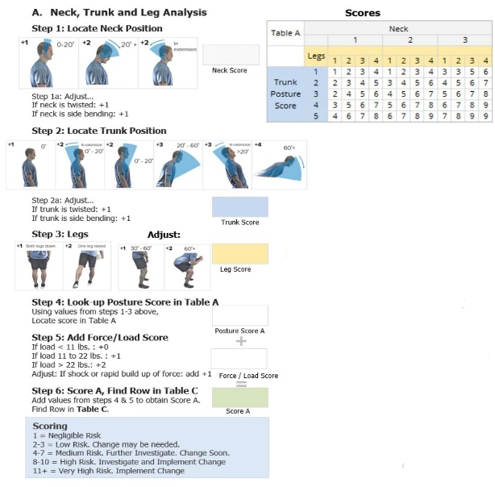 | 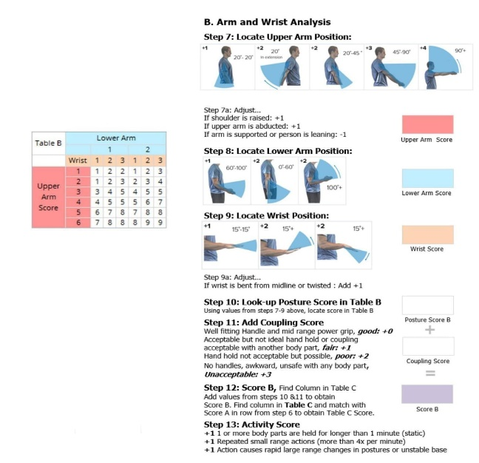
Figure 1. Initial stage of REBA calculation | Figure 2. Second stage of calculation REBA

The first step is to determine the position of the neck, where an assessment of the possible risks to the neck and posture is carried out by observing the magnitude of the neck angle formed between the torso and the neck position. Additional value variables are adjusted to the work posture, for example the neck is in a rotated or bent position (+1), and the neck is in a bent position (+1). The second step is to determine the position of the torso, by observing the angle formed between the tailbone and the back position. Additional adjustments are made if the back is in a rotated or turned position (+1), or the back is in a bent position (+1). The third step is a risk assessment of the legs, by paying attention to assessment categories such as the legs supporting the body in a balanced position (+1), or supporting the body with weight on one leg (+2). Adjustments are made based on the angle formed between the thigh and calf, for example if the leg angle is between 30°-60° (+1) or ≥60° (+2). The fourth step is to look at the posture score in Table A, determining the value based on calculations from steps 1-3. The fifth step is to add the load scores received by the neck, torso, and legs. The sixth step is to add up the values ​​in steps 4 and 5 to get score A which will be used in Table C. The seventh step is to determine the position of the upper arm, by observing the angle formed between the torso and the arm, and adjustments if the shoulder is raised (+1), the arm is away from the body (+1), or the arm has a support (-1). The eighth step is to determine the position of the lower arm by observing the angle formed between the upper and lower arm. The ninth step is to determine the position of the wrist by observing the angle formed between the lower arm and the palm, and adjustments if the palm is bent or rotated (+1). The tenth step is to look at the posture score in Table B, based on the calculation results from steps 7-9. The eleventh step is to add the coupling score to REBA to determine the possibility of additional loads received by the body posture position. The twelfth step is to add up the values ​​in steps 10 and 11 to get score B which will be used in Table C. The thirteenth step is to determine the risk value based on activities involving movement by the arm or wrist, such as static postures for more than one minute (+1), repetitive movements more than four times per minute (+1), or unstable or rapidly changing movements (+1). The final step is to determine the REBA.

METHODS
This research was conducted at one of the ports at PT. XYZ directly through the interview, observation and analysis stages for 2 days (March 14 and 22, 2024). The type of research in this study is qualitative research as a recommendation for systematic problem solving (Machali, 2022). The qualitative method was chosen because it has a clear systematic solution. This approach is used to facilitate data tracking in the company. Research data processing was obtained through the observation and in-depth analysis stages directly related to solving the problem of loading and unloading activities carried out manually with a total range of transport commodities of 25-50 kg per sack which can trigger unsafe actions, injuries, and other work risks or in other words known as Musculoskeletal Disorders (MsDs). The interview and observation stages were carried out directly with the authorities and related parties to loading and unloading activities, namely stevedores and Operational Staff of PT. XYZ. Direct and in-depth data collection was carried out so that information and analysis results were presented informatively and factually. Data processing sources consist of two criteria, primary data and secondary data. Primary data was obtained based on the results of interviews, observations, and direct analysis at the research location. The basis for the primary data findings is related to the research targets, in the form of the results of the Nordic Body Map questionnaire data and documentation data as a reference for the analysis of the Rapid Entire Body Assessment (REBA) method calculation to evaluate the risk of Musculoskeletal Disorders (MsDs) due to work accidents that tend to focus on postural body activities that are used as a whole from the posture of the neck, back, arms, wrists, and legs and as a comprehensive step to conduct criteria and tool dimensions tests that are in accordance with the operational needs of loading and unloading (Muslim, 2022, Bausad et al., 2022). The use of secondary data is used as a basis for strengthening primary data in data processing and solving problems in a solution-oriented manner based on additional secondary data sourced from literature such as books, articles, journals, and so on. The research data processing stage used the Nordic Body Map (NBM) questionnaire as a form of data processing with a subjective completion method and the use of the Rapid Entire Body Assessment (REBA) method as a measurement method for analyzing workers' abilities in carrying out physical activities in their work activities (Setiawan, 2022).

RESULTS

Nordic Body Map (NBM) Questionnaire Results Calculation
Pain intensity in various body locations before and after work in two domestic helper respondents. The pain locations analyzed included the upper neck, lower neck, shoulders, upper arms, back, waist, buttocks, elbows, lower arms, wrists, hands, thighs, knees, calves, ankles, and feet. The results showed a significant increase in pain scores after work compared to before work. In the upper neck, Helper 1's pain score increased from 2 to 5, while Helper 2's from 3 to 7. Back pain also showed an increase, with Helper 1 from 2 to 4 and Helper 2 from 4 to 8. A similar pattern was seen in calf pain, with both respondents showing an increase from a score of 2 to 4 in Helper 1 and from 4 to 8 in Helper 2. The left and right shoulders also experienced increased pain after work, reflecting the significant physical burden during their daily work. These data illustrate an increase in pain complaints in most parts of the body after work, indicating the impact of heavy physical work on the physical condition of the respondents. This information is important for developing pain prevention and management strategies, such as implementing better work ergonomics or physical exercise programs that can reduce the load on frequently affected body areas.

Table 1. Recapitulation of NBM questionnaire for porters before and after work
Pain Location | Before Work |  |  | After Work
Pain Location | Respondents |  | Pain Location Score | Respondents |  | Pain Location Score
Pain Location | Helper 1 | Helper 2 | Pain Location Score | Helper 1 | Helper 2 | Pain Location Score
Pain at the top of the neck | 2 | 3 | 5 | 3 | 4 | 7
Pain at the bottom of the neck | 2 | 2 | 4 | 4 | 4 | 8
Pain in the left shoulder | 1 | 2 | 3 | 2 | 4 | 6
Pain in the right shoulder | 1 | 2 | 3 | 2 | 4 | 6
Pain in the left upper arm | 1 | 3 | 4 | 2 | 3 | 5
Back pain | 2 | 2 | 4 | 4 | 4 | 8
Pain in the right upper arm | 1 | 2 | 3 | 1 | 4 | 5
Pain in the waist | 1 | 2 | 3 | 1 | 4 | 5
Pain in the buttocks | 2 | 2 | 4 | 4 | 4 | 8
Pain in the lower part of the buttock | 2 | 1 | 3 | 3 | 3 | 6
Pain in the left elbow | 1 | 1 | 2 | 1 | 1 | 2
Pain in the right elbow | 1 | 2 | 3 | 1 | 1 | 2
Pain in the left forearm | 2 | 2 | 4 | 3 | 4 | 7
Pain in the right forearm | 2 | 1 | 3 | 3 | 4 | 7
Pain in the left wrist | 1 | 1 | 2 | 1 | 3 | 4
Pain in the right wrist | 1 | 1 | 2 | 1 | 3 | 4
Pain in the left hand | 1 | 1 | 2 | 1 | 2 | 3
Right hand pain | 1 | 1 | 2 | 1 | 2 | 3
Pain in the left thigh | 1 | 1 | 2 | 1 | 3 | 4
Pain in the right thigh | 1 | 1 | 2 | 1 | 3 | 4
Pain in the left knee | 1 | 2 | 3 | 2 | 4 | 6
Pain in the right knee | 1 | 2 | 3 | 2 | 4 | 6
Pain in the left calf | 2 | 2 | 4 | 4 | 4 | 8
Pain in the right calf | 2 | 2 | 4 | 4 | 4 | 8
Pain in the left ankle | 1 | 1 | 2 | 2 | 2 | 4
Pain in the right ankle | 1 | 1 | 2 | 2 | 2 | 4
Pain in the left foot | 2 | 1 | 3 | 3 | 1 | 4
Pain in the right foot | 2 | 1 | 3 | 3 | 1 | 4
Individual Score

The attached data, the recapitulation of the NBM questionnaire of transport workers before work found the results of the individual score of helpers 1 transport worker of 39 and helper 2 transport worker of 45. The results of the recapitulation of the NBM data of transport workers 1 and 2 before work found that the individual score is within the vulnerable threshold of the “Low” scale, in this case the worker is in a fit body condition without serious injury which may not require any improvement recommendation efforts. The following data is attached to the recapitulation of the NBM questionnaire for transport workers after carrying out work activities as a reference for processing comparative data in the analysis of Musculoskeletal Disorders (MSDs) injuries. Based on the attached data, the recapitulation of the NBM questionnaire of transport workers after work obtained the results of the individual score of helpers 1 transport worker of 62 and helper 2 transport worker of 86. The results of the recapitulation of the NBM data of transport workers 1 and 2 after work found that the score per individual is within the threshold of the “Medium” and “High” scale, in this case after carrying out loading and unloading work activities, workers are in an unfit body condition with minor injuries and even serious complaints that require improvement recommendations. Based on the attached table data, it is presented that the score of the location of complaints that are at risk and complained about by porters is an attribute score with a value of 8, namely the location of complaints in the lower neck, back, buttocks, left calf, and right calf. The following table attaches the classification of the total individual score based on the recapitulation of the NBM questionnaire for porters to determine the scale of worker injury:

Table 2. Classification of injury risk levels based on individual final scores
Skala Likert | Individual Score | Risk Level | Action
1 | 28-49 | Low | No corrective action required yet
2 | 50-70 | Medium | Action required in the future
3 | 71-90 | High | Immediate action required
4 | 92-122 | Very High | Comprehensive action required

Calculation of MSDs with Rapid Entire Body Assessment (REBA) analysis
The analysis stage of the calculation test with the Rapid Entire Body Assessment (REBA) method was carried out with the same respondent sample test as the calculation analysis of the Nordic Body Map (NBM) questionnaire in the position of a porters' helper in loading and unloading activities at one of the docks at PT XYZ with basic transportation commodities such as rice, flour, etc. which weigh between 25-50 kg per sack, as well as the transportation of wood materials. The reference documentation of the posture of porters in loading and unloading activities comes from the documentation of researchers when carrying out direct visits through the stages of observation, interviews, and data collection as a research reference. In conducting the MSDs analysis test with the Rapid Entire Body Assessment (REBA) calculation, it is carried out by going through the analysis stage by classifying the calculation through the initial stage of calculating the position of the arms and wrists, the second stage of calculating the suitability of the neck position, back position, and legs, and the final stage of recapitulating the results of the analysis of the Rapid Entire Body Assessment (REBA) calculation in the loading and unloading performance activities at one of the PT XYZ docks. The results of the calculation analysis are attached in the summary table of the recapitulation of the Rapid Entire Body Assessment (REBA) calculation analysis for helper 1 and helper 2 porters loading and unloading laborers as follows:

Table 3. Recapitulation of REBA scores of Helpers 1 and Helper 2
REBA | Step | Angle/Description | Rate
Helper 1 | 1 | 177.8° + Bent forward | +2
Helper 1 | 2 | 46.7° + Bent forward hold | +3
Helper 1 | 3 | Leg Bend | +1
Helper 1 | 4 | Row 3 score + Column 1 score | 5
Helper 1 | 5 | Load > 22 lbs | +2
Helper 1 | 6 | Total step score (4 + 5) | 7
Helper 1 | 7 | 31.5° | +2
Helper 1 | 8 | 61.5° + Hand lifting to hold the load | +2
Helper 1 | 9 | 64.2° | +2
Helper 1 | 10 | Row score 2 + Column score 2 | +3
Helper 1 | 11 | Unsafe body position | +3
Helper 1 | 12 | Total step score (10 + 11) | 6
Helper 1 | 13 | Activity Score | +2
Helper 1 | 14 | Row score 7 + Column score 6 | 9
Helper 1 | 15 | Total final score (13 + 14) | 11
Helper 2 | 1 | 110.4° + Bent forward | 2
Helper 2 | 2 | 14.1+ Bent forward hold | 2
Helper 2 | 3 | Leg Bend | 1
Helper 2 | 4 | Row 2 score + Column 2 score | 4
Helper 2 | 5 | Load > 22 lbs | 2
Helper 2 | 6 | Total step score (4 + 5) | 6
Helper 2 | 7 | 72.4° + Forward bend | 4
Helper 2 | 8 | 73.7° + Hand lift to hold the load | 1
Helper 2 | 9 | 61.6° | 2
Helper 2 | 10 | Row score 4 Column score 2 | 5
Helper 2 | 11 | Unsafe body position | 3
Helper 2 | 12 | Total step score (10 + 11) | 8
Helper 2 | 13 | Activity Score | 2
Helper 2 | 14 | Row score 4 + Column score 8 | 9
Helper 2 | 15 | Total final score (13 + 14) | 11

The results of the MSDs calculation analysis using the Rapid Entire Body Assessment (REBA) method found a total final score for helper workers 1 and 2 of 11 based on the analysis of the 15 stages of calculations that had been carried out. The results of the Rapid Entire Body Assessment (REBA) data recapitulation found a risk score for classifying injuries to porters 1 and 2 while working, the score per individual was within the threshold range of the "Very High" scale, in this case when carrying out loading and unloading activities, workers were in a physical condition that was at risk of injury and serious complaints that required immediate recommendations for improvement right now. The following table is attached to the classification of the total individual score based on the recapitulation of the calculation results of the Rapid Entire Body Assessment (REBA) method for porters to determine the classification and risk level of workers:

Table 4. REBA Score Classification Recapitulation
Final Score | Risk Rate | Category | Action
1 | 0 | Very Low | No action required
2-3 | 1 | Low | May require Action
4-7 | 2 | Medium | Action required
8-10 | 3 | High | Immediate action required
11-15 | 4 | Very High | Immediate action required

Suggested Improvements
The analysis of the calculation results using the Nordic Body Map (NBM) questionnaire and the Rapid Entire Body Assessment (REBA) method which are within the high threshold and have the potential for injury and risk due to heavy workloads, causing a potential high level risk score and requiring improvement efforts as soon as possible. Based on the results of the analysis that occurred in the condition of porters' workers in loading and unloading activities at one of the loadings and unloading docks of PT XYZ, adjustments to work activities are needed. The workload carried out by porters with commodity weights reaching 25-50 kg per sack with arrival traffic and loading and unloading activities at the port can reach 40 ship arrivals per day. The operational stage at one of the docks of PT XYZ which is carried out manually with porters' labor can be fatal, dangerous, and an unsafe action activity that is risky for workers. The involvement of porters in full loading and unloading activities is also considered unable to run optimally due to limitations and decreased worker performance due to complaints and injuries that occur during work activities for a long time. The involvement of porters accompanied by adequate facilities and infrastructure can reduce the level of labor workload that is too heavy and can be one of the factors supporting the increasing productivity of loading and unloading operations. Therefore, it is necessary to propose improvements with the use and utilization of tools in assisting the loading and unloading process at one of the PT XYZ docks. The following is attached a proposed design for the use of supporting tools in the loading and unloading activities of one of the PT. XYZ docks.

Table 5. Proposed improvements to tools supporting loading and unloading activities
No | Supporting Tools | Improvements
1 | Cleated Belt Conveyor
1 | 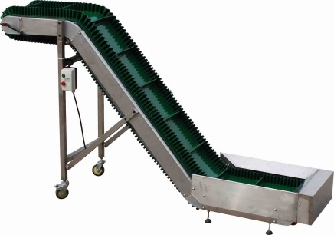 | - Tool to support the activity of moving goods from trucks to ships  - Supporting the activity of moving goods to the ship more quickly and efficiently  - Minimizing the workload of porters
2 | Roughter Crane
2 | 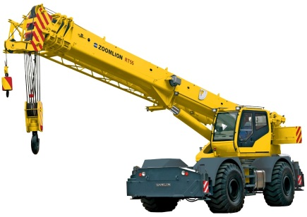 | - Tool to support the activity of moving goods from or to the bottom of the ship  - Supporting the activity of transferring goods to the ship more quickly with
3 | Modular Hand Truck
3 | 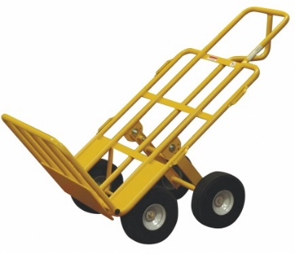 | - Tool to support the activity of moving goods from the base of the ship to the goods stacking room  - Minimizing the workload of porters
4 | Ladder Trolleys
4 | 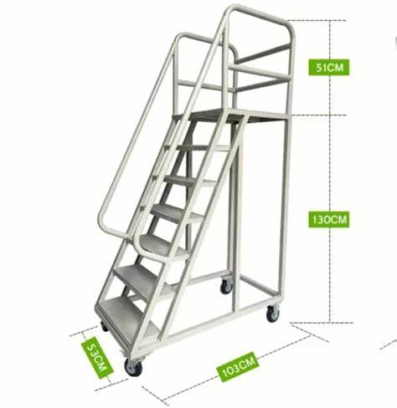 | - Tool to support the activity of stacking goods in the deck of the goods stacking room  - Minimizing the workload of porters

Based on a problem that can be identified from the results of observations that have been made of loading and unloading operational activities at the port of PT.XYZ, a work postural analysis is needed that can be a powerful technique for assessing the work activities of porters so that they can overcome a challenge that is comprehensively carried out quickly. Therefore, the analysis carried out must be recorded in the context of a thorough and continuous assessment of the workplace and ergonomic posture using the Nordic Body Map questionnaire and continued with calculations with the Rapid Entire Body Assessment (REBA) form. There are several factors that cause physical injury in the form of Work-related Musculoskeletal Disorders (WMSDs) that need to be avoided. This is closely related to the type of work, age, weight, work experience, gender, marital status and education level (Choobineh et all, 2013). The injury of porters is also related to their workload, the load lifted by an adult male should not exceed 40 kg and the physical load should not exceed 30-40% of his maximum work capacity for 8 hours a day. Based on these findings, work safety and security factors are very important to always be considered to increase productivity, efficiency and effectiveness of loading and unloading and as a problem-solving step that can be done selectively by paying attention to work posture.

CONCLUSION
The results of the calculation of work posture to 2 porters using the Nordic Body Map questionnaire before the activity shows individual scores of 39 and 45 respectively with a scale of “low” which does not require any improvement recommendation efforts. After doing the work, the individual scores were 62 and 86 respectively with a scale of “Moderate” and “High”, which requires immediate improvement recommendations. The level of complaints is very painful found in the lower neck, back, lower buttocks, left calf, and right calf. With the calculation of Rapid Entire Body Assessment (REBA), a score value of 11 is obtained with a scale of “Very High”, in this case the porters' activities require immediate improvement recommendations at this time. Proposed improvements made by procuring heavy equipment that supports loading and unloading activities such as: Cleated Belt Conveyor, Rougher Crane, Modular Hand Truck, and Ladder Trolleys. This tool is recommended to reduce the level of labor workload that is too heavy and is able to become one of the supporting factors for increasing the productivity of loading and unloading operations.

REFERENCES

- Agus, M. A. (2020). Peran Psikologi dalam Mengatasi Stres pada Narapidana. Psikologi Penjara: Penerapan Psikologi Dalam Proses Pemasyarakatan, 101.
- Bausad, A. A. P., KM, S., KM, M., & Allo, A. A. (2022). Kejadian Musculoskeletal Disorder Dari Segi Postur Kerja Dan Beban Kerja. Masalah Kesehatan Masyarakat: Pekerja Dan Remaja PutrI, 34.
- Hamdy, M. I., & Zalisman, S. (2018). Analisa Postur Kerja dan Perancangan Fasilitas Penjemuran Kerupuk yang Ergonomis Menggunakan Metode Analisis Rapid Entire Body Assessmet (Reba) dan Antropometri. SITEKIN: Jurnal Sains, Teknologi dan Industri, 16(1), 57-65.
- ILO. (2018). World Employment Social Outlook 2018: Greening with Jobs. International Labour Office.
- Ir Julianus Hutabarat, M. S. I. E. (2021). Dasar-dasar pengetahuan ergonomi. Media Nusa Creative (MNC Publishing).
- Jain, R., Meena, M. L., Dangayach, G. S., & Bhardwaj, A. K. (2019). Effect of individual and work parameters on musculoskeletal health of manual agriculture workers. International Journal of industrial and systems engineering, 32(1), 56-70.
- Joanda, A. D., & Suhardi, B. (2017). Analisis Postur Kerja dengan Metode REBA untuk Mengurangi Resiko Cedera pada Operator Mesin Binding di PT. Solo Murni Boyolali. In Seminar dan Konferensi Nasional IDEC (Vol. 2017).
- Lafau, Y. (2022). Redisain Alat Pencacah Dan Pengayakan Dengan Pendekatan Ergonomi Dan Biomekanika Pada CV. Mission Tani (Medan: Dissertation, Universitas Medan Area).
- Machali, I. (2021). Metode penelitian kuantitatif (panduan praktis merencanakan, melaksanakan, dan analisis dalam penelitian kuantitatif). Available at: https://digilib.uin-suka.ac.id/id/eprint/50344/
- Masniar, M., & Wijaya, R. T. (2017). perancangan standard paddock sepeda motor multifungsi menggunakan metode antropometri statis. Metode: Jurnal Teknik Industri, 3(1), 1-5.
- Muslim, A. A. (2022). Analisa Postur Kerja Terhadap Keluhan Musculoskeletal Disorder (Msds) Dengan Menggunakan Metode Ovako Work Analysis System (Owas) Pada Unit Penyortiran Barang (studi kasus di CV. Karunia Mandiri) (Semarang: Dissertation, Universitas Islam Sultan Agung).
- Nurdiana, M. (2020). Analisis Prosedur Operasional Bongkar Muat Petikemas Oleh PT. PELINDO III (PERSERO) Cabang Banjarmasin Pada Terminal Petikemas Banjarmasin (TPKB) (Kalimantan: Ddissertation, Universitas Islam Kalimantan).
- Rahayu, E. P., Ratnasari, A. V., Wardani, R. W. K., Pratiwi, A. I., Ernawati, L., Lestari, S., ... & Prasetyo, E. (2022). Kesehatan dan Keselamatan Kerja. Pradina Pustaka.

- Sasono, H. B. (2012). Port Management and Import-Export Realization. Yogyakarta: Andi.
- Septiani, N., Imron, M., & Purwangka, F. (2022). Postur Kerja pada Aktivitas Bongkar Ikan Tuna di Pelabuhan Perikanan Samudera Nizam Zachman Jakarta. Jurnal Teknologi Perikanan dan Kelautan, 13(2), 121-143.
- Setiaji, D., & Nurwildani, M. F. (2023, November). Analisa Postur Kerja Proses Inspection Kode Ip 058027 Dengan Menggunakan Metode Rapid Entery Body Assesment (Reba) Di Pt. Aneka Bonecom Component. In Prosiding Seminar Nasional Teknik Industri Pancasakti Tegal (SNaTIPs) 1; 158-169.
- Setiawan, A. P. (2022). Perancangan Jok Sopir Bus Dengan Analisis Nordic Body Map (Nbm), Rapid Entire Body Assessment (Reba) Dan Anthropometry Untuk Mengurangi Musculoskeletal Disorders Saat Berkendara (Semarang: Dissertation, Universitas Islam Sultan Agung).
- Shofwati, I., & Al Kaff, R. N. (2011). Faktor-faktor yang Berhubungan dengan Keluhan Nyeri punggung Bawah Pada Proses Penyulaman Tapis di Sanggar Family Art Bandar Lampung Tahun 2011. Available at: https://repository.uinjkt.ac.id/dspace/handle/123456789/26310
- Suhartono, R., Suhendar, E., & Wibisono, D. (2022). Analisis Dan Desain Meja Kerja Menggunakan Macroergonomic Analysis and Design Pada PT. Control Systems Para Nusa. Jurnal Teknologi dan Manajemen, 20(2), 81-88.
- Sukmana, E. P. (2022). Analisis Postur Kerja Dengan Menggunakan Metode Quick Exposure Check (Qec) Dan Metode Rapid Upper Limb Asessment (Rula) Pada Pekerja Pembuat Tahu Guna Menurunkan Risiko Musculoskeletal Disorders (Studi Kasus: UMKM MBAH SAWI TAHU) (Semarang: Dissertation, Universitas Islam Sultan Agung Semarang).
- Umboh, M. K., Malonda, N. S., & Mende, J. (2018). Analisis pengaruh posisi ergonomis dengan metode Rapid Entire Body Assessment (REBA) terhadap produktivitas kerja pada pekerja pengupas serabut kelapa tradisional di Minahasa Utara. Jurnal Tekno Mesin, 4(2).
- Wilson, J.R dan Corlett E.N., (1995). Evaluation of Human Work: A Practical Ergonomics Methodology. Taylor and Franchis Ltd, Londo.

